Buying vs. Renting a Property in Toronto - Project Proposal
27 October 2025

Submitted by Group 24:
Matteo Van Der Plaat
Brandon Tate
Daniel Heron
Joel Prosser

Faculty Supervisor:
Mariam Guizani

Executive Summary
This project revolves around the idea of forecasting home prices. This problem has been solved in the past using highly simplified calculators such as one created by The New York Times [4], however this project is interested in determining if it’s possible to improve upon those methods with newer innovative machine learning algorithms. By researching the academic world, it can be found how this has been done in the past and compare past models to modern AI and machine learning techniques. The objective of this project is to implement these new machine learning methods, while integrating the intuition from the past, to more accurately forecast the Toronto housing market better than ever before.
This document includes background information on the problem, the scope of the project, datasets, the machine learning algorithms to be used throughout the project, as well as a list of predetermined features that will be useful to guide the process of creating a complex neural network. The execution section shows how the selected algorithms will be implemented and used to predict throughout the delivery of the project. Each of these algorithms is suited for the problem and will not only be compared to the results of previous methods but also to the results of each other. These include Support Vector Machines, Neural Networks, and XGBoost. The execution section also includes how each of the models will be trained. Finally, the delivery shows which programs and applications will be used to implement this project, as well as the concept for the final output.
The estimated cost of this project is about $70. Some milestones to look forward to include creating a finalized dataset incorporating all disparate sources, selecting and optimizing a model to predict off that data, and developing the final output to display predictions.

Table of Contents
Executive Summary 2
1. Introduction 5
1.1 Project Description 6
1.1.1 Scope 6
1.1.2 Assumptions 7
1.1.3 Preparations 7
2. Functional Description 8
2.1 Previous Solutions 8
2.2 New Solutions 10
2.3 KNIME 12
2.4 Google Colab 12
2.5 Output 13
3. Design and Production Approach 13
4. Testing and Evaluation 15
4.1 Training and Testing Method 15
4.2 Evaluation 16
5. Resource Requirements 16
5.1 Software Requirements 16
5.2 Data Requirements 16
6. Conclusion 17
7. References 18
Appendix 20
Data sources to be used throughout the project 20

Table of Figures
Figure 1 - SVM Architecture Example 11
Figure 2 - Neural Network Architecture Example 12
Figure 3 - Training Example 16

Introduction
In 1985, the median detached home price in Toronto was just over $100,000 with a median family income of $30,000 after tax [3][5]. Most families with a reliable income and some savings would be able to afford a home or qualify for a good mortgage within the first few years of their working career. In 2025, the average detached home price in Toronto is just below $1,200,000 marking a 1100% increase in the span of a single generation [6]. In that same time span, the average household income in Toronto has increased by nearly 200%, to $85,000 annually after tax [5]. This disparity between the growth of the housing market and the growth of real household wages serves as motivation for this project.
Young adults of today are looking at a vastly different real estate landscape than their parents did at the same age several decades ago. The notion that homeownership is the holy grail of investments is finally being put into question. The bar to entry is so high now that people are choosing (or being forced into) renting instead of owning. While this might seem like a great loss to the generation that profited greatly from the real estate golden age of the last 40 years, those people seem to underestimate the strength of the stock market during the same time period. On January 1, 1985, the S&P500 was valued at a peak of 180 points [2]. On January 1, 2025, the same index was valued at a peak of 5935 points [2], marking an incredible 3200% increase – notably higher than that of the Toronto housing market. While volatility does play a part in investment decisions, the strength of the market cannot be ignored in this discussion.
This project aims to provide an alternative to young adults feeling hopeless when faced with paying an average of nearly $1,000,000 for a 700-800 sq ft condo in downtown Toronto [1]. By taking years of historical data on housing prices into account alongside relevant data related to demographics and economics, this project aims to predict the landscape of the housing market 20 years from now. With this information in hand, prospective home buyers will be able to make an educated decision to build their wealth and maximize their well-being.
This will be done by using highly detailed public datasets published by Statistics Canada (StatsCan), the Canada Mortgage and Housing Corporation (CMHC), the Bank of Canada (BoC), and more that will be discovered throughout the process of execution. These datasets will be fed into cutting-edge machine learning models such as XGBoost to produce an output that will give an accurate outlook on the housing market in Toronto in 20 years time. This output will then be compared against the alternative of renting a comparable property and investing the surplus money into a reliable stock market index fund such as the S&P500. The final result will be a tool where prospective home buyers can access an in-depth financial analysis of renting a property in Toronto and investing in the stock market vs. buying a property in the city. Additional information will also be provided to users such as cut-off points (e.g. if rent is below XXX per month, it is more profitable to rent) and percent certainty (e.g. in 60% of cases it is more profitable to buy vs. rent) to allow buyers to make the most informed decision possible. Further details on the scope, methods, and final product to deliver can be found below.

1.1 Project Description

1.1.1 Scope
The scope of this project entails predicting the state of the housing market of properties that lay within the boundaries of the City of Toronto as defined by the StatsCan census. This includes using machine learning algorithms to determine the most important factors that affect the housing market, then training and executing a regression algorithm to predict future prices based on that. The algorithms to be used and tested in the scope of this project include Support Vector Machines, Neural Networks, and XGBoost. This project does not include implementing any previous tried and tested solutions to this problem such as the NPV calculator as used by The New York Times [4].
The length of time being predicted is 20 years ahead, predicting farther into the future is not in the scope of this project. All neighbourhoods of Toronto, and non-subsidized property types will be included in the analysis. This project will not touch on housing affordability in Toronto based on wages, the focus will simply be on determining the most profitable option between buying and renting a property in Toronto, no matter the relative affordability (or unaffordability). It is also not in the scope of this project to explicitly predict major events that affect housing such as the COVID-19 pandemic or 2008 financial crisis; however, the resulting market movements and the frequency of these events will be factored into predictions due to the fact that it is interwoven with the data. Predicting the future value of rental markets and/or the stock market is not in the scope of this project. All dollar values and percent increases are in nominal terms. Additional expenses associated with renting and buying will be calculated into the final prediction for each option (e.g. maintenance/upkeep, taxes for owners, utilities for both owners and renters, etc.).

1.1.2 Assumptions
Below is the list of assumptions used to generate the scope of this project. The list is not exhaustive but lists the key assumptions required to make this project useful and feasible.
- It is assumed that both buyers and renters will maintain the same property for the whole duration of the 20 years considered in this project.
- This project assumes that rent will increase linearly at the government maximum rate of 2.1% per year [7] and that the S&P500 will return 10.54% per year – its nominal average annual rate of return since 1957 [8].
- By predicting using past trends in the housing market, this project inherently assumes that there are discernible patterns in housing market trends that predictions be based on.
- The relative stability of the housing market, rental market, and stock market is also assumed by the nature of this project.

1.1.3 Preparations
As the housing market in Toronto is incredibly nuanced and complex, lots of data is required to create a full and accurate prediction. The focus of this project will be on best optimizing large datasets and executing machine learning models based on the most impactful features. Below are examples of features that are highly impactful on the housing prices and thus would be key to solving this problem based on intuition.
Housing Market Data
- Sales Volume (number of homes sold, market activity)
- Inventory / Listings (how many houses are on the market)
Economic & Financial Data
- Bank of Canada Rate / Prime Lending Rate
- Inflation (CPI, shelter inflation specifically)
Demographic & Social Data
- Age Distribution
- Migration trends

All of this information is available directly from reliable government sources. Housing market data is available directly from CMHC [9], demographic and social data is available from the City of Toronto open data portal [11], and economic data is available directly from the Bank of Canada [12]. CMHC and City of Toronto data are both pulled directly from the national census put out by StatsCan every 5 years [10]. Additional sources of data will be added as they found throughout executing this project. More information about data sources can be found in the appendix under Data sources to be used throughout the project.

Functional Description
This section will look at previous solutions that have been used to solve this problem, as well as new solutions involving machine learning. KNIME is one of the chosen programs to normalize, cluster and train the data. Once the KNIME model shows accurate predictions there will be another model created. Google Colab is the other application that will be used to implement the solution.

2.1 Previous Solutions
This problem has been solved in the past without using machine learning. It is important to understand these previous solutions to see which methods have shown success and how can machine learning be used to improve these previous solutions. The main solutions to this problem have been linear regression, net present value math, cash flow analysis and ARIMA models.
The New York Times has a net present value (“NPV”) calculator in which you plug in known values about a property for sale, as well as some values for a property on the rental market, and it can calculate what the most profitable option would be for individual cases. Some of these criteria include home price, rent, mortgage rate, investment return on savings (if you rent, what do you do with the money saved?). This method of solving the problem is useful for individual cases where users are trying to decide between two comparable properties in the present moment, but does not consider future economic trends, housing market trends, demographic trends, etc. The goal of this project is to take that guess work out of the calculator and attempt to predict market trends to provide a more accurate, holistic prediction – not just an NPV calculation.
AutoRegressive Integrated Moving Average (“ARIMA”) models are another solution to this problem. The Canadian mortgage and housing corporation use models like these to provide answers however they are better at solving much shorter time periods (1-3 years in most cases). These models are used because they work with smaller datasets, they handle seasonality quite well (Canadian housing is very seasonal) and they can give you accurate results without having to use more advanced machine learning. There are also limitations to these models. ARIMA models assume that there are linear relationships however the housing market is influenced by many factors that are complex and often non-linear. Things like interest rates and immigration affect housing prices, however they are non-linear relationships.
Our goal is to create a model that will outperform current methods by implementing machine learning algorithms to predict market trends. The next section will include the methods that can be used to solve this problem.

2.2 New Solutions
There are multiple machine learning algorithms that can be used to solve this problem. Some of the more applicable ones include Support Vector Machine (“SVM”) models, Neural Networks and Extreme Gradient Boosting (“XGBoost”). These algorithms handle high dimensionality, and they are also highly researched. Since they have been used for other similar projects like predictions in mineral deposits for mining, the results from those projects can be used to help create a solution to this financial analysis.
SVM models are useful when trying to understand a smaller dataset. The datasets from the Toronto market are considered smaller datasets in terms of machine learning (thousands of data points instead of millions). SVM models are also efficient at understanding highly dimensional data. Extra dimensions or features like population and immigration will be implemented into the datasets by combining multiple datasets and quantifying certain categories. Some examples include month of year / season and unexpected events like COVID or stock market crashes and fluctuations. SVM models are also easier to tune than many other machine learning algorithms like neural networks. The only problem with SVM models for this project is the fact that when making predictions the data point will be given a class prediction. Therefore, instead of an exact prediction of price it will have to be a range between $50 000 – $100 000. A screenshot of an example architecture diagram is shown below.
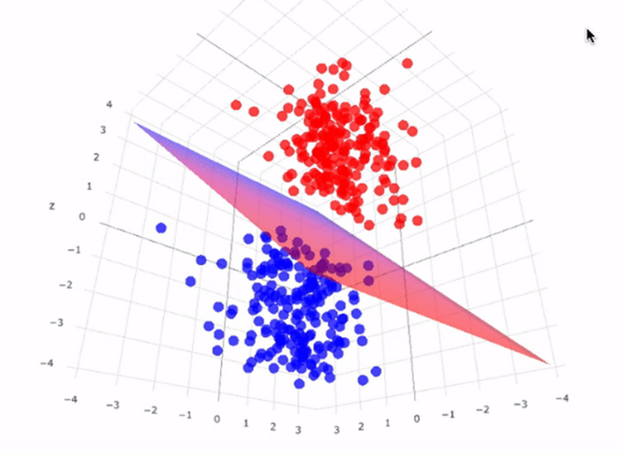
Figure 1 - SVM Architecture Example
This architecture diagram shows how SVM models classify different data points. The hyperplane changes based on features and the outputs of the training data. The best hyperplane corresponds to the midline of the thickest surface that can fit between datapoints of the classes. For this project there will be more classes to fit all of the price ranges needed for the predictions.
Neural Networks work with larger datasets however are still accurate with smaller datasets. Neural Networks also gain advantages with high dimensionality. By adding more information about each individual piece of data you have the neural network can begin to determine which features are useful to the model. This may cause certain features to have greater impact than was initially thought by economists. Weights inside of the neural network will change when the model is training which is what causes certain features to have varying levels of impact on the output. Each feature is assigned an initial weight and by accessing each of the weights you can then determine the value of each feature. Although these models are more complicated, they will generally return better results if they can be tuned properly. Unlike SVM models Neural Networks will be able to make an exact prediction of the price since the results do not have to be tied to a class (although they can be). A screenshot of an example architecture diagram is shown below.
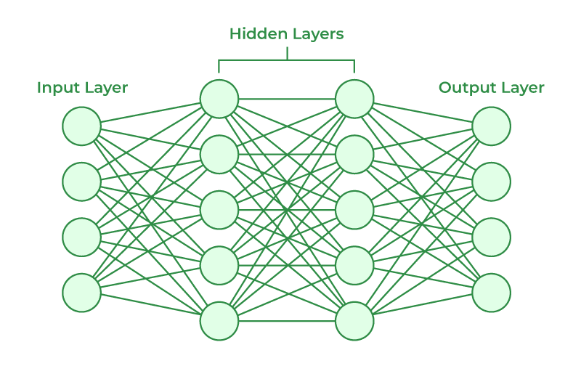
Figure 2 - Neural Network Architecture Example
There are three main aspects of the Neural Network. Those are the input layer, hidden layers and the output layer. The input layer is where the data enters the network. Each input node corresponds to one feature of the data. The hidden layers perform computations and try to extract patterns from the input layer. This is where weights are changed as explained before. Finally, the output layer produces the final prediction of the network. This problem will use a regression output and a multi-class classification. The regression output will give an exact house price estimate, and the multi-class classification will give a range like the SVM model.
XGBoost is a machine learning algorithm that builds multiple decision trees to make its predictions [13]. Gradient boosting refers to starting with a single tree and continuing to add new trees to the model. Every new tree added attempts to fix the problems of the previous tree. The combination of these trees gives you your final prediction. This algorithm is good at understanding non-linear relationships. Many of the features used in this solution will be non-linear and therefore this is a potential model to solve the question.
Each of these algorithms have pros and cons to solve this problem. To receive the best results all 3 models will be made and compared to each other to see which of the 3 performs best. The best model will then be used as the final prediction for housing prices.

2.3 KNIME
KNIME is a data analytics and machine learning platform that uses connecting nodes to modify data and perform AI algorithms. This program allows simple data input and output. The machine learning algorithms are already implemented in the program, and the simple models will show which of the previous algorithms can solve this problem most efficiently. The SVM and Neural Network models made in KNIME will be tied to a prediction within a range ($50 000 – $100 000).

2.4 Google Colab
In order to train machine learning models with abundant data, lots of computing power is required. Google Colab is a program which can take your code and run the long training times with cloud GPU’s. This project will likely need to use Google Colab or have access to highly powerful GPUs in order to train the models being created. Once the KNIME models show us results for all algorithms Google Colab can be used to fine tune the initial KNIME model. The new Neural Network made in Google Colab will now not be tied to a range and can make an exact prediction unlike in KNIME.

2.5 Output
Along with the prediction of the machine learning algorithms, the aim of this project is to produce a more in-depth financial analysis on buying vs. renting in Toronto as output. Including cutoff points for when buying or renting may be more profitable, and percent certainty on the prediction.
Building off this if all goes beyond expectations, the project could also further break down buying vs. renting by property type or by specific neighbourhood of Toronto to add further utility. An interactive web application could be used to display the applicable data for users. This would take inputs of neighbourhood and property type to determine whether the user should rent or buy given those requirements, and provide the analysis discussed above. A highly optimistic yet intriguing way to implement this would be to work with an interactive map that would provide the analysis by hovering over certain neighbourhoods in the city. Users would receive a brief overview until clicking into a neighbourhood for further details.

Design and Production Approach
The production approach of the project will be split into four major phases to achieve the most efficient and best possible outcome for the software and technology. Due to the project being entirely consistent of software and digital data, it will not necessarily have certain construction phases but rather just developmental phases. Each phase will be detailed below with their contingency plan as well as their division of labour. Below as well are the expected dates for outcomes and internal deliverables assuming the project is successful without the need for contingencies. Due to the majority of October being taken up by the fall break, proposal + blueprint deliverables, TA meetings and midterms the projects major phases are scheduled to start in late October/Early November as seen below.
Phase 1 will run from November 1st to November 28th and consist almost entirely of the research, gathering, organization, and input of all training data and materials the project will need. This will consist of necessary group meetings as well as dividing up areas of research among the group in order to gather differential data as efficiently as possible. One person can focus on gathering information on sales volume/the inventory of the housing market over time. Another person would gather things such as mortgage rates, Bank of Canada rates as well as inflation rates. The other two members can gather data on human geography and social trends such as age distribution in homebuying/ownership, average age of home buyers, migration trends and age of sellers. The group can then organize all this data into a single teams file or google drive for easy access and distribution. This phase is a month long as it will be the most research intensive and time consuming outside of testing and training. This plan has no contingency as the group already knows where to retrieve this data and from what sources as explained above.
November 29th to January 7th will not be scheduled for anything specific due to exams and the winter break.
Phase 2 will run from January 8th to January 21st. This phase will consist of the actual coding and development of the various software's in which will be trained. This phase will also consist of the necessary group meetings as well as individual work to complete this phase effectively. During this phase the group will split into three sections, two single and one duo. One person will work on developing the support vector machine for the task at hand due to it being able to handle smaller data sets. Another group member will work on developing the software that implements the Extreme Gradient Boosting, this is the software the group is hoping will work the best. However, apart of the greater contingency plan, is having more than one available model so that if one or more models do not work in the way that is expected, there are other options. Lastly, another pair of people will work on the design, development and implementation of a neural network model. This model will be assigned to two people as it will most likely be the most time consuming and complex.
Phase 3 and 4, although two separate and distinct phases, will intersect and involve one another, especially during the testing iterations. Phase 3 is using KNIME on the developed algorithms in order to optimize and normalize, cluster and train them. Phase 3 also includes the Google Colab training on the optimized and selected models. Phase 4 consists of the testing and evaluation of the algorithms, specifically the one that was chosen to optimize the most due to promising early results. The first iteration of phase 3 (ex the first training) of the models should run from January 22nd to February 6^{th.} The ending of this would trigger the beginning of phase 4. If all were to be theoretically perfect, testing and fine tuning would be unnecessary/hardly required allowing fourth phase to be as short as a week ending on February 14th. However, the group is aware that this is a very unlikely and rare situation/scenario. The contingency plan of these phases would be more time to finetune and train. Therefore, the internal deadline is to be finished by February 14th . Nevertheless, the final presentation is not until March 17th giving over a month of “runoff time” to use for continued fine tuning and training if needed. The tasks for these phases will be divided by having the people who worked on certain models/software's to also train those models. Once one model is chosen, the group will work together in experimenting/researching ways to continue improving/fine tuning that model.

Testing and Evaluation

4.1 Training and Testing Method
Predictions will be generated for 10 to 20 years into the future using all available historical data. Model training and tuning will be performed through a nested loop approach. For example, with 50 years of data, a minimum training window of approximately 30–50% of the dataset can be selected. The process then proceeds by incrementally extending the training set, adding one year at a time at each step. The screenshot below illustrates how the training procedure operates.
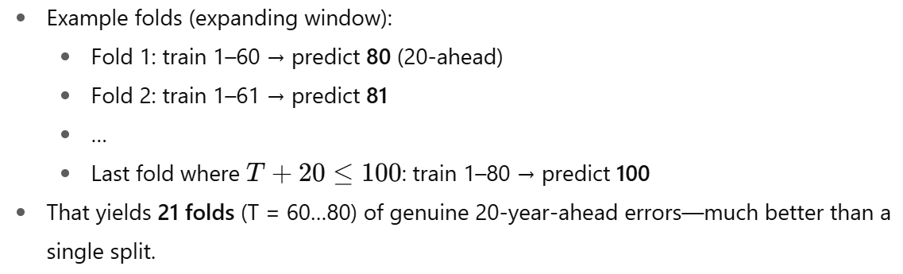
Figure 3 - Training Example

4.2 Evaluation
After training on the complete dataset, the model produces testing outputs by refitting the historical data and generating a single 20-year forecast. This forecast can be produced without incorporating future estimates of variables such as population and economic indicators. However, incorporating educated projections of these variables is expected to improve prediction accuracy.

Resource Requirements

5.1 Software Requirements
Since this is a software-based project there are no hardware components needed. The only resource needed for this project is a Google Colab subscription. The subscription costs $13.99 per month. Based on the timing of training the model this will cost between $28 and $70.

5.2 Data Requirements
This project will also require the use of publicly available datasets published by reliable government sources such as the StatsCan census, Bank of Canada economic data, and various CMHC reports. More details on these can be found in the appendix under Data sources to be used throughout the project.

Conclusion
The goal of this project is to provide a conclusive prediction, based on past and present states of the housing market in Toronto, what is currently more profitable for the average prospective homeowner – buying a property, or renting a property and investing extra funds into the stock market. This is fundamentally what the project strives to answer. Paired with some additional financial analysis such as cutoff points and percent certainty, the aim is to make a tool to better guide anyone considering entering the Toronto housing market.
By combining extensive datasets and applying modern machine learning techniques (such as SVMs, Neural Networks, and XGBoost) to them, this project looks to improve upon the previous solutions of rigid financial calculators and oversimplified forecasting [4]. The final output will allow prospective homeowners to make informed, data-driven financial decisions at one of the most critical points in their lives. For many Torontonians facing record-high property prices and stagnating wage growth [3], this project aims to provide information on a potential alternative to buying a home, which has become the status quo throughout the golden age of the housing market. Ultimately, the objective of this project is to help demystify some aspects of the housing market, challenge previously unquestioned assumptions about home buying, and offer some better guidance to wealth building for the young adults of today.

7. References
[1] Realtor.ca, 2025. https://www.realtor.ca/map#view=list&Sort=6-D&GeoIds=g30_dpz89rm7&GeoName=Toronto%2C%20ON&PropertyTypeGroupID=1&TransactionTypeId=2&PropertySearchTypeId=3&SQFTRange=700-800&OwnershipTypeGroupId=2&Currency=CAD.
[2] “S&P 500 (^GSPC) Charts, Data & News - Yahoo Finance,” finance.yahoo.com. https://finance.yahoo.com/quote/%5EGSPC
‌[3] “Now and then: Do Canadian homes really cost that much more than 30 years ago?,” financialpost. https://financialpost.com/personal-finance/mortgages-real-estate/now-and-then-do-canadian-homes-really-cost-that-much-more-than-30-years-ago
‌[4] M. Bostock, S. Carter, A. Tse, and F. Paris, “Is It Better to Rent or Buy? A Financial Calculator.,” The New York Times, May 10, 2024. Available: https://www.nytimes.com/interactive/2024/upshot/buy-rent-calculator.html
‌[5] Statistics Canada, “Income of individuals by age group, sex and income source, Canada, provinces and selected census metropolitan areas,” Statcan.gc.ca, Apr. 26, 2024. https://www150.statcan.gc.ca/t1/tbl1/en/tv.action?pid=1110023901
‌[6] “Toronto Median Price | CREA Statistics,” creastats.crea.ca. https://creastats.crea.ca/mls/treb-median-price
‌[7] Government of Ontario, “Residential rent increases,” Ontario.ca, 2021. https://www.ontario.ca/page/residential-rent-increases
‌[8] J. B. Maverick, “S&P 500 Average Return and Historical Performance,” Investopedia, Dec. 26, 2024. https://www.investopedia.com/ask/answers/042415/what-average-annual-return-sp-500.asp
[9] “Housing Market Information Portal,” CMHC, 2024. https://www03.cmhc-schl.gc.ca/hmip-pimh/en/TableMapChart/Table?TableId=1.1.1.8&GeographyId=2270&GeographyTypeId=3&DisplayAs=Table&GeograghyName=Toronto#TableMapChart/2270100/6/Mount%20Pleasant%20West.
‌[10] Statcan.gc.ca, 2020. https://www150.statcan.gc.ca/t1/tbl1/en/tv.action?pid=1010013901
‌[11] “Open Data Dataset.” https://open.toronto.ca/dataset/neighbourhood-profiles/
‌[12] “Statistics,” Bankofcanada.ca, 2019. https://www.bankofcanada.ca/rates/
[13] XGBoost Developers, XGBoost Documentation – stable version, Available: https://xgboost.readthedocs.io/en/stable/
‌

‌

Appendix

Data sources to be used throughout the project
- Demographic Data by Toronto Neighbourhood: https://open.toronto.ca/dataset/neighbourhood-profiles/
- Housing Data by Toronto Neighbourhood: https://www03.cmhc-schl.gc.ca/hmip-pimh/en/TableMapChart/Table?TableId=1.1.1.8&GeographyId=2270&GeographyTypeId=3&DisplayAs=Table&GeograghyName=Toronto#TableMapChart/2270100/6/Mount%20Pleasant%20West
- Housing Market Data pre-CMHC: https://trreb.ca/wp-content/files/market-stats/market-watch/historic.pdf
- Bank of Canada, money market and other interest rates: https://www150.statcan.gc.ca/t1/tbl1/en/tv.action?pid=1010013901
- BoC Stats: https://www.bankofcanada.ca/rates/

